

Complaints by Parents Policy - Federation

FORTUNATHENA

F E D E R A T I O N

Updating Policy Procedure

When a policy is due for review it will be emailed to the reviewer who will revise and highlight those updates and return the policy in full with the highlighted updates back to the Administrator.

When a policy reviewer becomes aware of any updates they will ask the Administrator to email the policy to them and follow the above procedure.

A policy is a statement of intent and the guidelines we follow, that is adopted by the Fortuna and Athena Federation’s Governing Body.

H Keegan - Fortuna
Policy Reviewed by:

November 2025
Updated on:

September 2026
Date to be reviewed:

Date ratified at FGM:
23 February 2026

Introduction
All maintained schools in England are required to have a procedure in place for dealing with complaints relating to the school and any community facilities or services that the school provides. There are certain complaints which fall outside of this procedure because there are established statutory or other prescribed procedures available, for example, staff grievances or disciplinary procedures; school admissions; exclusions; statutory SEN assessments; Child Protection procedures; public examinations; school reorganisation proposals.
At Fortuna and Athena school, all staff are dedicated to giving all children the best possible education and caring properly for their health, safety and welfare at all times. We are committed to working closely with parents/carers and believe that school and parents/carers must work together in partnership; each carrying out our own particular responsibilities to help pupils gain the most from their time in school. We also desire to have good relations with our neighbours and the wider community.
If you have any concerns around any aspect of your child’s experience at school or feel we are not doing something that we should be, we want you to tell us about it. That way we can work together to remain solution focused to resolve any issues that may arise.

The First Step — Informal
Please contact the school office to arrange to discuss any concerns with your child's class teacher, or with the particular teacher concerned. We hope that most problems can be sorted out this way. If you are not the parent/carer of a child at our school, please start at the second step and make contact with the Headteacher to discuss your concerns.

The Second Step — Informal
If, after speaking to your child's teacher and having allowed sufficient time to deal with the issue, you do not feel that your concern has been properly dealt with. Alternatively, if your concern is about the conduct of a particular teacher, then you should discuss the matter with the Headteacher or a member of the senior leadership team. You can contact the school office to make an appointment with the Headteacher.

The Third Step - Formal
If your attempts to resolve the matter informally have not been successful, you should make a formal written complaint to the Headteacher.
If your complaint is about the conduct of the Head teacher you should make a formal written complaint to the Chair of Governors, addressing your envelope to the Clerk to Governors, care of the school's address. If for some reason you do not feel able to put your complaint in writing, please contact the school office to arrange an alternative means of capturing your complaint.
You will receive an acknowledgement from the Headteacher (or Chair of Governors where additional stage is adopted) within five school working days. The acknowledgement letter will also indicate the date by which you can expect to receive the Headteacher’s/ Chair of
Governors written response to your formal complaint letter. This will normally be within ten school working days from the date of the acknowledgement letter.

Taking Matters Further — Governors' Review
If you are dissatisfied with the Head teacher’s response to your formal complaint letter, then you will need to contact the Clerk to Governors who will convene the Governors' Complaints Committee,
You should send written details of your complaint with any correspondence and evidence to support your complaint, to the Clerk to the Governors at the school address. If, for some reason, you do not feel able to do so, you should contact the Clerk, via the school, who will record your complaint as a statement for you to sign,
The Clerk to Governors will write to acknowledge receipt of your complaint within five school working days. The acknowledgement letter with explain the process which is to be followed and the expected timescale for that process — please see the section 'Governors Complaints Committee Procedure'. Where your complaint is considered under written representations, this process may take up to twenty-eight school working days to allow for the collection of representations and evidence.
The Governors' Complaints Committee will consider your complaint and write to advise you of the outcome within the timescale provided by the Clerk to Governors.

Complaints Against Individual Governors
For complaints against the Chair of Governors, or any other individual governor, you should send written details of your complaint, with any correspondence and evidence to support your complaint, to the Clerk to the Governors at the school address. If, for some reason, you do not feel able to do so, you should contact the Clerk via the school, who will record your complaint as a statement for you to sign.
The Clerk to Governors will acknowledge receipt of your complaint within five school working days and initiate the correct process. The Chair of Governors will consider complaints against an individual governor and the Vice Chair will consider complaints against the Chair of Governors.
The appropriate governor will consider your complaint and write to advise you of the outcome within ten school working days. There will be no further internal right of appeal for complaints against individual governors.

Complaint Procedure Timescales
We will use our best endeavours to address complaints in a timely and efficient manner; however, there will be times when timescales may need to be adjusted. If, at any stage of the process, we believe we are unable to meet the timescales which have been provided to you, the Clerk will contact you to explain the reasons for any delay and to provide you with a new timescale for the conclusion of that part of the process.

External Appeal
The decision of the Governors' Complaints Committee is normally final; however, if you are dissatisfied with their response, you may be able to take your complaint to an external body.
For certain complaints about schools maintained by the Local Authority, complainants can write to the Secretary of State for Education, You must do this in writing, either by post to:

School Complaints Unit
Department for Education
2nd Floor, Piccadilly Gate
Manchester

Ml 2WD
Or, by using the online School Complaints form. This can be accessed at:

https://www.qov.uk/complain-about-school
You should be aware that the School Complaints Unit (SCU) will usually only consider a complaint once the school's internal processes have been exhausted. The SCU will examine whether the complaints policy and any other relevant policies were followed in accordance with the provisions set out. The SCU will also examine whether the school's policies adhere to education legislation. The SCU will not usually re-investigate the substance of the complaint.
Please note that, unless your complaint is about the governors' response or lack of response, your complaint will generally have to be considered first by the governing body of the school
GOVERNORS COMPLAINTS COMMITTEE PROCEDURE refer also to the flow chart at the end of this section
General Principle:
      - If a person is not satisfied with the response from the Head teacher, or from the Chair of Governors, then he/she is entitled to take the complaint to the Governing Body's Complaints Committee.
      - All complaints to the Governing Body's Complaints Committee must be in writing and should include full details of the complaint, along with any supporting evidence. This should be sent to the Clerk to the Governors, care of the school. The Clerk will then ensure the complaints process is started as soon as practicable, if for some reason you do not feel able to put your complaint in writing, please contact the Clerk to arrange an alternative means of capturing your complaint.

- A minimum of three governors should be selected from a bank of nominated governors to form the Complaints Committee to consider the complaint The Chair of Governors will not usually sit on this committee. Those governors chosen should ideally have no knowledge whatsoever of
the details surrounding the complaint or of the complainant themselves. The Complaints Committee can choose its own Chair.

- It is appreciated that it may not always be possible to find governors with no knowledge at all. However, the Governing Body should use their best endeavours to find governors who are as impartial as can be. If this proves particularly difficult in any given case, the Clerk to Governors should contact the School Liaison Officer for further advice on how to proceed.
- Once the Complaints Committee has been formed, members of the Complaints Committee must ensure they are familiar with the school's complaints procedure. They must then decide how they wish to consider the complaint.
- Governors effectively have two options available. They can choose to deal with the complaint by means of an oral hearing or through written representations, but in making their decision they must be sensitive to any needs the complainant has. The LA advises that} wherever possible and appropriate it should be through written representations.

Oral Hearings
If the governors choose to have an oral hearing, the Clerk to Governors will invite the complainant to attend a meeting where they will be able to put their complaint personally to the Governors' Complaints Committee The complainant should receive not less than ten days' notice of the meeting (calendar days). The complainant should also be advised that they have the right to submit any further information or documentation relevant to the complaint and that this information should be received in sufficient time so it can be provided to the Committee at least five school working days before the hearing. They should also be informed that any written materials will be provided to the Head of School in advance of the hearing.
- The Clerk to Governors should inform the Headteacher of the time and date of the meeting, invite him/her to attend and provide all the details of the complaint available at that time, so that the Headteacher can provide a written report in response to the complaint. This report should be provided at least five school working days before the meeting so it can be shared with all parties.
- The Headteacher should attend the oral hearing to respond to the complaint. Teachers should not attend. If their evidence is needed, it should either be obtained via the Headteacher, or where this is not appropriate, by a governor either before or after the meeting with the complainant. Written evidence should generally be made available to all parties at least five school working days in advance of the hearing, subject to any data protection constraints. Governors should seek advice from the Legal Services Officer with responsibility for Data Protection matters if there are concerns as to what materials can be shared. The governors will only make a decision about the complaint once they have heard the complainant's and the school's evidence.

- The structure of such a meeting should be flexible. However, it is anticipated it will follow a similar process to admission appeals. The Chair of the Committee should outline the procedure. The complainant will then present his/her case. The Complaints Committee should have familiarised themselves with the written complaint before the meeting opens and will then have an opportunity to ask any questions, as will the Headteacher. The complaint should then be responded to by the Headteacher and both the complainant and the Committee will have the opportunity to ask questions. Each party can then be asked to summarise their position in brief. Both parties will then leave to allow the Committee members to make their decision in private. The complainant and the Headteacher should enter and leave the room at the same time; neither should be alone with the Committee.

- Both the complainant and Head teacher are entitled to bring a representative with them if they wish. Although it would not normally be necessary, either party may bring a legal representative if they wish. Either party intending to bring a representative would be expected to contact the Clerk to the Governors before the hearing to notify them.
- The hearing should be clerked and the DfE advise that it is best practice to share copies of the minutes with all parties involved in the hearing; affording them a reasonable opportunity to agree and if necessary challenge their content.

Written Representations:
- If the governors do not wish to hold an oral hearing - that decision being at the discretion of the Complaints Committee - the consideration will proceed by way of written representations.
- Should the governors choose to adopt this procedure, the Clerk to the Governors will write to the complainant, outlining the procedure.
- The complaint will be forwarded to the Head of School who will then have 7 school working days in which to respond.
- That response will then, in turn, be sent to the complainant for comment, any responses to be provided within 7 school working days.
- Finally that response will go to the Head of School who has 7 school working days in which to respond to the Clerk.
- A copy of the Headteacher’s final response should be sent to the complainant with the advice that it is only for their information and that any further response will not be considered except in exceptional circumstances.
- All the responses are then put before the Complaints Committee for consideration.
- For the avoidance of doubt, all communication should be through the Clerk to the Governors, neither party should send their response to the other directly.

Adjudications
- Regardless of which method is adopted, the Complaints Committee should take a robust approach and not simply endorse the decision of the Headteacher without any consideration of the evidence.
- The Complaints Committee must have all the necessary evidence they feel is necessary for them to make their decision. If they are not satisfied and require further evidence from either party they should adjourn and request that information. The Complaints Committee should only make their decision if they are satisfied they have sufficient evidence with which to make a final decision.

- The decision of the Complaints Committee should be given to the complainant in writing within 5 school working days of the decision. Providing the procedures as laid down in the complaints policy are followed then there is no right of appeal following this decision.
- The decision letter should outline the nature of the complaint, the factors taken into consideration and the decision of the Complaints Committee. In the case of written representations, the decision letter should be sufficiently thorough so as to obviate the need for minutes to include any other information.
- Under the Data Protection Act, complainants can request to have sight of alt documents relating to their complaint, subject to restrictions as detailed in I-CC guidance 'Disclosure of Information to Parents and Others'.
It is important that the complaint and associated papers are not attached to a child's file as they do not relate to the child.
However, schools are advised to keep a central register of complaints received. The DfE advise that the monitoring and review of complaints can be a useful tool in evaluating a school's performance.

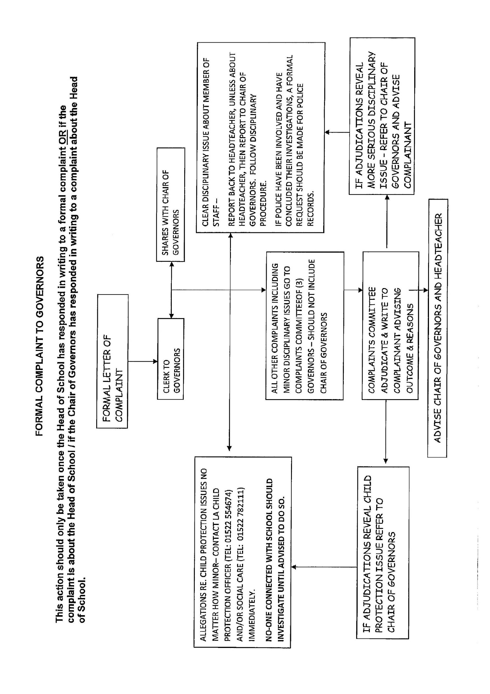

OTHER MATTERS:
Safeguarding Referrals:
Schools have a duty to safeguard and promote the welfare of their pupils under section 175 of the Education Act 2002. Where members of staff have a concern about the welfare of a child, they have a duty to make a referral to the appropriate organisation, usually Local Authority Children's Social Care Services. It is not for the school to investigate or make a judgement about possible abuse or neglect but they must refer any concerns they may have. As such, complaints about safeguarding referrals made in accordance with a statutory duty will not be considered under this procedure.

Time Limits for Raising Complaints:
You should make the school aware of your complaint as soon as possible after the matter or incident has occurred that you wish to complain about. Usually, we would expect you to do this within three months of the incident occurring and if you do not contact the school within that time, we will not usually consider your complaint
If your complaint relates to a continuing act, then occurrences outside of the three month time limit will usually be considered alongside the more recent occurrence.
If you feel there are exceptional circumstances that have prevented you from meeting the time limit, you can provide an explanation of these circumstances along with your complaint so that Governors can take them into account.
The final decision rests with Governors as to whether your complaint will be considered when it is raised outside of the three month time limit. In addition, where your child is no longer on roll at the school and your complaint is considered exceptionally, it will usually only be possible to have your complaint considered under the final stage of the school's procedure.

Unreasonable Complainant Behaviour:
Staff and Governors are keen to ensure that all genuine complaints are dealt with fairly and promptly and in accordance with our agreed procedures. We would again emphasise that most matters can be resolved by discussing issues with our staff at the informal stages of our procedure.
Regrettably, there are times when complainants raise issues with or about staff in ways which are unacceptable. This can cloud the concern at the heart of the complaint, which may result in the delay or hindrance of a resolution. It can also have an adverse effect on pupils, staff and the effective running of the school. Examples of behaviours that we consider to be unacceptable are as follows:
- Refusing to articulate their complaint or specify the grounds of a complaint or the outcomes sought by raising the complaint, despite offers of assistance;
- Making excessive demands on school time by frequent, lengthy, complicated and stressful contact with staff regarding the complaint in person, in writing, by email and by telephone while the complaint is being dealt with.

- Introducing trivial or irrelevant information which the complainant expects to be taken into account and commented on, or raises large numbers of detailed but unimportant questions, and insists they are fully answered, often immediately and to their own timescales.
- Making unjustified complaints about staff who are trying to deal with the issues and/or harassing individual staff members in a way which appears intended to cause personal distress rather than to find a resolution;
- Refusing to cooperate with the complaints procedure as set out in this policy; while still wishing their complaint to be resolved;
- Refusing to accept that certain issues are not within the scope of a complaints procedure;
- Changing the basis of the complaint as the consideration proceeds and/or making unjustified complaints about those trying to deal with the complaint;
- Pursuing unreasonable outcomes which are disproportionate to the nature of the matters in hand;
- Persisting in repetitious complaints when these have been previously determined under the school complaints procedure;
- Electronically recording meetings, telephone calls and conversations without the prior knowledge and consent of the other persons involved;
A complainant's behaviour may also be considered unreasonable if the person making the complaint does so either face-to-face, by telephone or in writing or electronically:
- maliciously;
- aggressively;
- using threats, intimidation or violence;
- using abusive, offensive or discriminatory language;
- knowing it to be false;
- using falsified information;
- publishing unacceptable information in a variety of media such as in social media websites and newspapers
Complainants should limit the numbers of communications with the school while a complaint is being progressed. It is not helpful if repeated correspondence is sent (either by letter, phone, email or text) as it could delay the outcome being reached. In addition, the school expects that any person wishing to raise a concern or complaint will;
- Follow the school complaints procedure.
- Treat all members of the school community with courtesy and respect.
- Recognise the time constraints that staff operate under and allow them a reasonable amount of time in which to respond / address any issues.

Where a complainant raises a complaint in a manner which the school feels is unreasonable, actions may be taken to remedy this. The actions will be proportionate to the nature of the behaviour and may include:

- An informal approach to inform the person that the behaviour is unacceptable and needs to be modified.
- A formal written communication advising the person that the behaviour is unacceptable and appropriate action may be taken if the behaviour is not modified.
- A tailored communications strategy such as limiting the method and/or frequency of contact with staff / school personnelA refusal to register and process further complaints about the same or similar subject matter where the matter has already been determined, or where complaints are vexatious, or where complaints are personally harassing, or deliberately targeted at one or more members of staff without good cause.
- Setting restrictions on the person's access to the school site.

In respect of the last point, it should be noted that parents/carers and members of the wider community do not have an automatic right to enter school grounds and may be barred from entering the school site with immediate effect following any incident where behaviour has been verbally and/or physically aggressive.
In the event of such behaviour, the school will write to the person concerned to advise that his/her licence to enter the school premises has been temporarily revoked, subject to a review of the decision. The letter will invite the individual to put forward his/her views as to the ban and also advise how he/she can appeal the decision. The decision will then be reviewed and the ban either confirmed or lifted. If the decision is confirmed, the person will be notified in writing and advised how long the ban will be in place
Any restrictions placed on a person as a result of this policy will be time limited, with a specified date as to when the restrictions will be reviewed and potentially lifted. The period of review will usually be three months; however, for more serious breaches, this may extend to a period of six months.
Again, we would emphasise that the Head of School and Governing Body are committed to ensuring a full and fair consideration of all legitimate complaints and we recognise that the majority of parents/carers and members of the wider community will conduct themselves in accordance with this policy. However, we reserve the right to take any necessary actions under this policy in those rare cases where a person does not.

(Note: No complaint should be summarily dismissed as vexatious but should be carefully assessed first Caution should be exercised before taking any of the actions outlined above and responses must be proportionate. Further advice and support are available from the LA & School Community Liaison Officer.)

