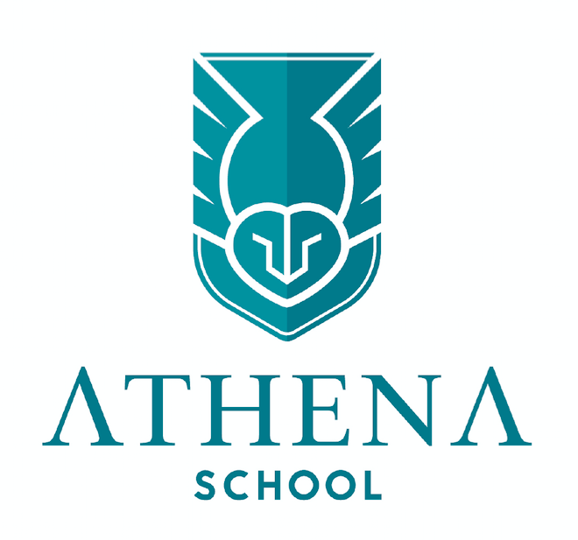  Your school needs you!!!!!  We are looking for new members for a team of Librarians.  What are Librarians?  Librarians have the job role of being in charge of organising and issues books, films and audio files from the library. Their duties are to issue out resources for people to use from the school library.  What jobs are there?  Each year, our school will normally choose a number of librarians to look after the library, give out books and other resources to the other students in the classroom.  Within this role you will:  - Sort the library out.  - Keep the library tidy.  - Ensure the books are kept in the right sections.  Email olivia.allard@athenaschool.org.uk or vicky.seaman@athenaschool.org.uk to express an interest
  What do I need to do to apply?
  Fill in the application form
  Attend your zoom interview
  What commitment does it take?
  Attend regular meetings
  Attend training for the role
  Take a lead on World Book Day
  Get involved in all school library initiatives
  Keep the library well organised and tidy
  Who do I need to talk to about this role if I am unsure?
  Miss. Allard
  Mrs. Seaman

