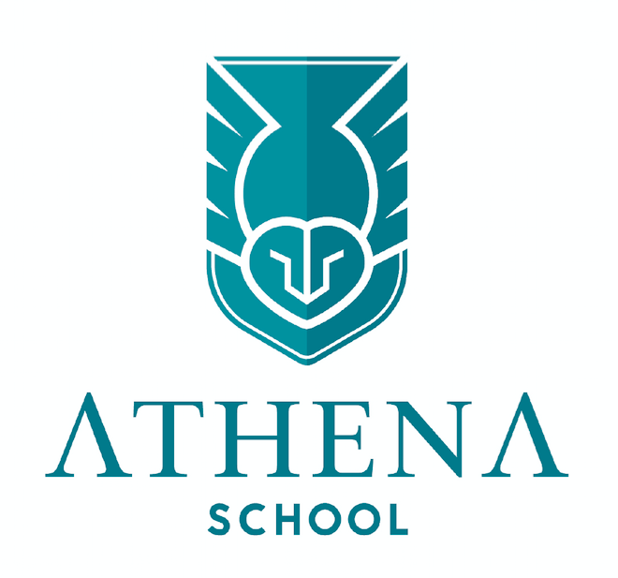  Your school needs you!!!!!  We are looking for new school council members.  What is a school council?  A school council is group of students who are chosen to represent the views of all pupils and to improve their school.  What jobs are there?  Each year, our school will normally choose a number of representatives to be members of the school council.  The council will then meet to elect officers such as:  - Chair – host the meeting, ensure everyone has a say  - Secretary – take down notes from the meeting  - Treasurer – note down potential costs of ventures  Sub groups will then be formed – ‘Mental Health and Wellbeing’, ‘School Environment’ and ‘Social and Fundraising’.  Email rhian.turnbull@athenaschool.org.uk or Leanne.taylor@athenaschool.org.uk to express an interest.
  What do I need to do to apply?
  Fill in the application form
  Attend your zoom interview
  What commitment does it take?
  Attend regular meetings
  Attend training for the role
  Hold class discussions to share information
  Get involved in all school council initiatives.
  Who do I need to talk to about this role if I am unsure?
  Mrs. West
  Miss. Turnbull
  Miss. Taylor

