


Nurture Policy - Federation

Updating Policy Procedure

When a policy is due for review it will be emailed to the reviewer who will revise and highlight those updates and return the policy in full with the highlighted updates back to the Administrator.

When a policy reviewer becomes aware of any updates they will ask the Administrator to email the policy to them and follow the above procedure.

A policy is a statement of intent and the guidelines we follow, that is adopted by the Fortuna and Athena Federation’s Governing Body.

H Keegan – Fortuna School
Policy Reviewed by:

26/11/25
Updated on:

Date to be reviewed:
September 2026

23 February 2026
Date ratified at FGM:

Nurture Policy

(See also Child development/play policy)

This document attempts to outline some of the principles underlying the ‘nurture’ philosophy. It is a vehicle for discussion and reflection with all staff.

Statement of Purpose:
The Fortuna Athena Federation is a specialist provision working with Primary and secondary age children who experience severe social, emotional and behavioural difficulties.

The Children:
The children referred to our service exhibit a wide spectrum of challenging behaviour. Each child arrives with a unique set of circumstances and an individual profile. Generalised descriptions of behaviour are unhelpful but it is useful to identify some common features in the children’s early experiences that have contributed to their difficulties.

In some cases the children’s early nurturing experiences have been interrupted, fragmented and in some cases abusive and traumatic. Their emotional and social development has been impinged upon in the early years. The children lack the solid foundation that a sustaining, untroubled nurturing provides. Instead they struggle to make sense of the world from a disadvantaged viewpoint and their responses become inevitably more out of line with their peers as they enter school. Their impulsive and inappropriate behaviour bears witness to the missing nurturing early years.

The children are emotionally immature and will often appear and behave as much younger children. They seem to be “stuck” at an earlier developmental level. At times they are reminiscent of an omnipotent toddler demanding their own way at all costs. Equally they can present as a dependent baby relying on the constant closeness of the adult to feel safe.

For some children early attachments have been damaged and they find it hard to bond and attach to even familiar adults. They children lack trusts in the intentions of the grown-ups and can resist any attempts to form relationships. They test the adults as much as they can before they will take the risk to rely upon them or accept guidance from them. In this way the children can appear self-determined and overly self-reliant.

The children exhibit extreme behaviour at times, which may include destructive and violent outbursts. Some of these episodes can be regarded as “tantrums” familiar in a toddler. They are often provoked by an adult thwarting the child’s wishes or simply insisting on a “no”. Alternatively, some children express out of control behaviour which is best described
as “panic” or “rage” and places the child in danger to himself and others and requires careful supervision and long term help from the carers.

It is not always easy to recognise the triggers which tip a child into destructive episodes. Sometimes a sound or touch will remind them of a past suffering and instigate a panic attack or rage, which appears to overwhelm them.

As we begin to have a deeper understanding of each child it becomes easier to predict the onset of panic. It also becomes possible to recognise when a child’s initial belligerent stance is a desperate need to control events. Some children have been at the mercy of chaotic conditions and have learned how to take charge for themselves. Any attempts to undermine their dominance will insight a battle. Being in control can represent a fragile security for the child and having lived with massive uncertainty it is not something to relinquish lightly. A child may escalate into full-blown rage and subsequently into panic rather than surrender the need to control the situation.

A child may have little self-preservation. They place themselves in danger and have no understanding of the consequences of their actions. Often they are unable to think before they react. They are impulse driven and forethought is not yet a process they employ. At the beginning we do their thinking for them and they learn from us.

Many of the children have had some very tough and painful experiences to deal with. They do not as yet have the skills to understand and overcome their worries. Some have survived by kicking and screaming out their distress. Others have developed patterns of behaviour which hinder their healthy growth and development.

Peer group relationships are fraught for most children. Learning to make friends is a slow and arduous process. For our children it is doubly hard. They are fundamentally egocentric and therefore find all sharing, giving and taking unpalatable. They cannot perceive another’s point of view and are often slow to feel empathy for another child. Remorse and reparation for any injury they may inflict are qualities which take time to learn and internalise. They are quickly envious and view any nice experience happening to another child as a direct injury to themselves. They perceive any negative remark as persecution and become very aggrieved with the perpetrator.

The children have no boundaries and will not at first recognise any attempt to moderate their behaviour. They will try anything to re-establish themselves as in a position of power. In many cases they have had to be “in charge” of themselves and have become compulsively self-reliant. They are not about to readily take on the rules and restrictions imposed on them by an unknown adult.

The children find any change problematic. It is a measure of their insecurity that they cannot tolerate any uncertainty no matter how small. For instance, any change in routine can tip them into chaos. Life may never have felt safe and predictable and so any minor alteration can remind them of an imminent crisis.

Faced with so many facets of behaviour, which are complex and difficult to change, we could easily become overwhelmed and pessimistic. We might also begin to concentrate on the
child’s problems and find ourselves in a negative cycle. Although we certainly need to be insightful and work with the child to overcome their difficulties, this does not constitute the focus for our intervention.

Our school is a nurturing school and our main purpose is to find the healthy growing point of each child and to provide them with the experiences which encourage them into healthy and emotional maturity.

We concentrate on what is going right and build on the positive abilities of the child. We reach them at the growing point and build a scaffold around them to support their tentative climb to maturity.

The thrust of our work is to look forward with hope and not backwards with despair.

The Nurturing Approach
Our purpose is to prove the early learning experiences that will nurture the children socially, emotionally, behaviourally and intellectually. Our aim is to educate and heal.

Nurture Principles:

As a federation we base much of the work we do with the pupils around the 6 Nurture Principles (Nurture UK). These principles act as the foundation for key policies and practise within the schools and often provide the balm or the putty to some of the developmental gaps identified through The Boxall Profile assessment.

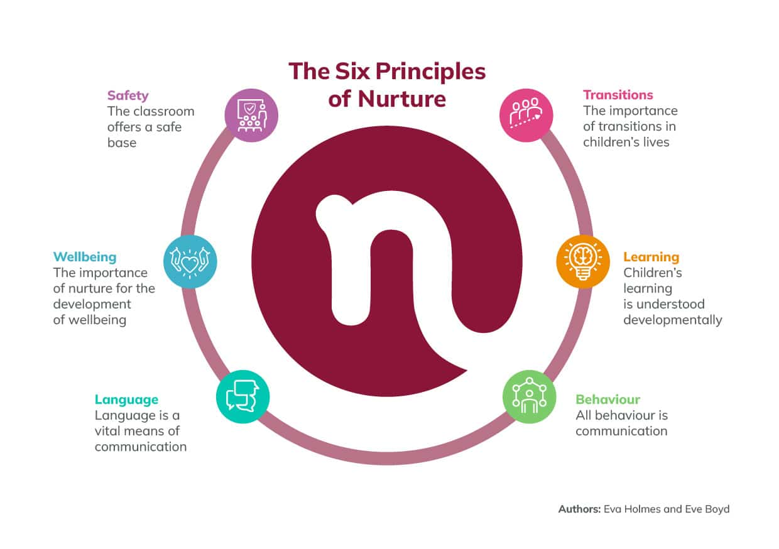

The Nurture Environment

Within the classroom setting staff will create an environment which is safe, secure and nurturing.

Furniture and fittings need to be maintained at a high standard and take into account the predisposition of the children to explore and seek danger. Just as parents of wilful toddlers alter their living space to adapt to the changing needs of the children then so must we. Children should understand the particular functions of rooms and be able to learn the rules surrounding certain areas. The environment should be orderly and clean but allow for the normal disarray in a family home. The children are encouraged to respect their surroundings and to take shared responsibility for keeping their classes acceptably organised.

Our children are vulnerable to any dangers within the environment and extra caution is needed with regard to health and safety issues. The children do not readily understand the dangers implicit in everyday situations and need to be guarded against them.

A warm and pleasing environment is vital in demonstrating to the children how much they are valued. An ambience is generated which acts as an intangible container for “holding” and “anchoring” the children. The care and attention to detail implicit in home making is an essential ingredient in preparing a nurture environment.

The Nurture Day:

It is necessary to bring order and predictability into the sometimes chaotic lives of the children. This is not to imply oppressive control but rather to underline the necessity for the children to experience a safe and predictable world. As an infant learns to expect the arrival of warmth and sustenance so our children begin to feel safe in the predictability of events.

We introduce patterns into the daily activities. Familiar routines punctuate the day and serve to slow the pace of the children.

Transitions are often flash points for outbursts. The children have to be prepared for any change however small. The changeover from school time to play time has to be handled carefully and almost seamlessly for the children to retain their composure.

Movement from one activity to another can also precipitate distress and children have to be rehearsed and gently prepared for the introduction of change.

Good beginnings and endings are crucial.

The children need to know the satisfaction of completing an experience. If they are engrossed in an enjoyable activity and this is brought to an abrupt end an angry outburst may be instigated. Where possible we make it possible for the children to wind down an activity, giving them plenty of guidance and reassurance as they do so. Remember they are emotionally very fragile and quickly become frustrated and helpless if their best efforts are inadvertently spurned and cut short.

How a child begins the day can affect the whole day. Mornings may hold anxiety for the child. If they have had a nightmare or wet the bed, or have feelings of hunger they misinterpret, all these factors can affect their mood. Particular routines need to be established for individuals where possible and the child should be included in devising them. Small details put in place make all the difference. It is in the detail that we make the child feel safe and settled.

The Nurturing Content:

The focus of our work is to provide a sustaining nurturing experience for the children.

It is also fundamental for professionals working with challenging children to recognise that in order to provide the essentials which lead to healthy growth we will have to provide added extras.

An understanding of early child development and the implications of deprivation or unsettled or interrupted early development.

A strong belief in the ability of the children to change.

An understanding of our own emotions, reactions and responses when dealing with the children.

To help each other to work creatively through a shared commitment to enhancing the lives of the children.
To share responsibility for the children and to hold in high esteem the importance of our work.

Relationships – Secure beginnings
A baby experiences unconditional love. They grow confident in the actions of their carers and are secure in a world where their needs are unquestioningly catered for. They learn the feelings of security and well-being and can sleep peacefully in the expectation that they will be safe. Parents shield their baby from any outside influence that may distress or bewilder them. Although a child may become upset or be in pain, the adults do everything in their power to minimise the chances of any long-term damage to the child. The parents love the child unconditionally and their thoughts are preoccupied with the needs of this new life.

We recognise that our essential task is to build close and bonding relationships with the children. This is the cornerstone of our work. We offer unconditional acceptance of the child and although we will often disapprove of the behaviour this never extends to the child. As a good parent we will “stick” with the child through their difficult times and work with them towards a solution.

Our patience will be tested to the limit and it is necessary to remain adult at all times. The children have mastered ways to push the most sensitive hidden buttons and we need to be aware of how we can be made to feel. We are all vulnerable and subject to our own insecurities. It is important we know ourselves in order to be able to withstand the testing delivered by the children. We have high expectations of our own professionalism and we need to remind each other and ourselves regularly that how we are behaving towards the children is the essence of our task. Our checklist might include:

Consistence – insistence – persistence
served with
care and concern
mixed with
understanding and intelligence
topped with
endless humour and bags of stamina

Positive relationships:

With some children forging a relationship will be a one-way ticket for quite some time. We may need to begin at the beginning and establish that important mother – baby eye contact. Often the children will avoid this and activities may need to be devised in order to gain it, often through play. Through our consistent interactions the child will gradually learn to trust the adult and bond with them.

The relationships between adults and children are positive and trusting and founded on mutual respect. We practise how to really listen to the child and we teach them how to really listen to others. They learn how to adopt the strategies we offer them to help understand themselves. They trust that in speaking about their difficulties a solution can be found. They realise that circumstances can change and that they have the power to make changes.

These positive relationships give the child an enhanced self-esteem and they feel important and valued. They develop real thinking skills and engage in the learning process.

In time it will be necessary to allow the child to become more self-determined. They will begin to make more decisions regarding their futures. It is important that we know when to “let go” and to empower the child to walk alone. This is part of a process that is undertaken with them from the onset of their time at Fortuna. From the first day the children are working towards a successful leaving. The process involves regular risk assessment on the part of the carers and close monitoring of the flexibility of provision. The closeness of the relationships ensures a thorough knowledge of the children which is our best guide in gauging how much independence they can manage.

Our ultimate aim is that the children can learn to manage their own behaviour and we can separate from them. As any “parent” we carefully measure the amount of support that is needed as the child matures. We are always ready to bring them back if they have wandered beyond their depth. At all times we stay alongside the children as the relationship follows a natural course.

As a federation, we always hold hope and aspiration for some of our pupils to be able to successfully re integrate back into a mainstream setting. We will consider the views of parents and professionals in making any decisions around re integration.

Play (See also play policy)
Many of our children need to learn how to play. These opportunities form a part of each school day and are carefully curated to support individual pupil’s.

We may have to begin at the baby stage where the adult encourages the baby to smile and the baby enjoys the playful behaviour inherent in these early communications.

Gradually we help the child to play with objects and toys and to know the joy of being absorbed in a world driven by their own imagination and curiosity. The child becomes absorbed in the wonders of these pastimes and learns how to engage in activities, to concentrate and to learn. The child experiences control in the play situation and can direct the course of events and exercise power in a safe and non-threatening situation.

Eventually, we will be able to help the children learn how to play with other children. At first the adult will take the major role and the child will need maximum guidance and direction to maintain the play as a positive experience. Like children at playgroup, it is the adults who do the work. The children left to their own devices soon lose the plot and mayhem ensues. They are able to participate in parallel play alongside another child but any attempts to manoeuvre them into comradeship will take patience and time. Soon they will begin to share and with supervision will be ready to join in with other children. That is when the adult can feel that all the rehearsal time was worthwhile. Once the children can play together they can begin to make relationships with each other and a peer group develops.

At this point the children are ready to attempt cooperative play and although the fallings out and the necessity for reparations are frequent the children have passed through several play stages. They are much better equipped for dealing with disappointments and squabbles and are on the road to making friendships.

Learning to make and keep friends is a life skill and play is the child’s training course.

Play and play resources are vital to our purpose and it is necessary to read the play policy in order to feel confident in understanding the level of play needed for individual children. It is also necessary to be familiar with the resources needed to meet children’s needs. Play rekindles their curiosity. It absorbs them in meaningful activity. It teaches them how to concentrate and how to think.

Play is the child’s real work.

Learning in School
The children referred to our service have experienced repeated failure in the mainstream school setting. In the majority of cases they demonstrated unmanageable behaviour at the onset of their infant education and despite receiving extra support they were unable to adjust.

School presents enormous obstacles for children who have not yet mastered the early social skills required in a large group situation. There is an expectation that children will be generally biddable and willing to participate in the enjoyment of school life. Our children are largely defiant, egocentric and unwilling to compromise. They find being a member of the group foreign and unpalatable as they are reluctant to share, take turns, give and take or accept anything other than instant gratification.

Their behaviour is uninhibited and difficult to moderate. Their formal learning is hindered by their emotional immaturity, they risk falling behind in all aspects of school life and their fragile esteem is further crushed by repeated failure.

As a setting, we must ensure that we are supporting them through these challenges and cultivating a safe environment and trusting relationships so that they feel safe enough to, over time, develop a sense of belonging and value as a part of a small group. The federation has an inclusive approach where pupils learn from staff to be accepting of the help that others may need, in the safety that they know they will receive the support they need to.

They develop trust that the adults can keep everyone safe and that they each have a place and are valued for who they are. The challenges they have faced do not define them but over time they learn from the safety of the adults around them how some of these challenges can impact the way they see things and can make things feel more challenging for them. In being explicit and open with the pupils we help them to understand that the difficulties they face are not because of them, but likely as a result of some of the experiences they have faced. This breaks down narratives, over time, around feelings of shame that they may carry and constantly feeling like an outsider and why they cannot do what peers in other settings around them can seemingly do so easily. It supports them in the belief that change is possible.

We want to provide our pupils with a community in which they truly belong. We must recognise their challenges and use careful support and scaffold to support them to be able to be a part of a group. This is a fundamental life skill that they will need to be successful in later life.

We must ensure that pupils are met at their growing point and provided with learning activities that are engaging and initially feel safe; with the intention of developing their sense of worth and self esteem. As relationships and trust grows, the pupils feel safer in being able to take risks with their learning and accept challenges presented by the teacher. This is where the academic growth can really be witnessed. Over time the pupils begin to see themselves as learners and that they can achieve whatever they set their mind to; they just needed the right support.

The Nurture School
Our priority is to provide an educative setting where our children can become positively involved with learning.

The aim is to recognise the potential of each child and ensure that they access a broad and balanced curriculum.

Our response is to establish the philosophy and practice of Nurture Education.

The nurture classes have a high staff ratio. One teacher and two assistants support up to ten children.

The classroom environment is carefully structured. It allows for a whole spectrum of work and play activities to co-exist. It incorporates a domestic setting that allows for early, pre-school experiences to take place.

Space is carefully structured and provides enclosed areas where children feel anchored and secure, alongside more open areas that allow for group play and free movement.

The children embark on a nurturing process that provides the early learning experiences necessary for the child to engage in the learning process. The child gains a solid foundation education on which to build all future learning.

The curriculum is delivered within the framework of the nurture group and individual and group social needs form part of the school day. The emotional needs of the children are catered for and the learning matches the maturity of the child and the pace at which they can absorb and engage in the set tasks.

At Fortuna, pupils follow the Play curriculum, which is directly linked to The Boxall profile and provides opportunities for pupils to develop their social, emotional and developmental needs.

Expectations are high and the children are encouraged through a culture of praise and positive reinforcement. They are supported and encouraged to attempt the challenges set for them and any achievement is celebrated. The work is initially presented in bite-size pieces in order for the children to taste success. Gradually, as befits the nurturing process, the child begins to tackle more demanding tasks and develops the capacity to think for himself.

At Fortuna the play curriculum runs alongside the individual learning targets identified on the Educational Health care plans.

The National Curriculum is followed throughout the school and the children are entered for end of key stage assessments. A broad, balanced and bespoke curriculum is planned and implemented which acknowledges the need for variety and relearning.

The learning tasks are differentiated to account for a range of abilities and individual learning styles.

Assessment:

The educational assessment includes formal testing and ongoing teacher assessments. Emotional and developmental milestones are assessed using the Boxall Diagnostic Profile and the Fortuna behaviour log.

Daily monitoring and individual educational records all assist in tracking and monitoring the child’s development throughout their time in our community. It is through this process of continual assessment that we are alerted to particular needs of children. Specialist teaching assessments may be utilised to identify specific learning areas.

Assessments undertaken by a psychologist or psychiatrist may be required. The necessity for additional support is identified through careful monitoring and child focus meetings.

Staff Training:

All adults in the community are inducted into the ethos and expectations of the school. They are fully committed to the nurturing ethos and the aims of therapeutic education. Senior members of staff continually lead by example and junior members are able to “shadow” more experienced practitioners during their induction period. This training is invaluable and equips new staff with a shared language, a wealth of strategies to use in challenging situations and an insight to the stamina required to cement relationships with the children. In order for the children to attach and form positive bonds an emotional commitment is necessary. This is equally true of the adults.

Communication with outside agencies:
Our children often arrive with a network of professionals working with them and their families. Close co-operation and shared decisions are initiated at the beginning of the child’s placement and these links are maintained throughout the child’s stay. The federation strive to make positive and professional relationships with all agencies involved with pupils attending the schools. This is paramount to communication.

Educational and Looked After Children reviews include all relevant agencies and the child is encouraged to attend.

