Pay and Staffing Policy- Federation
Updating Policy Procedure

When a policy is due for review it will be emailed to the reviewer who will revise and highlight those updates and return the policy in full with the highlighted updates back to the Administrator.

When a policy reviewer becomes aware of any updates they will ask the Administrator to email the policy to them and follow the above procedure.

A policy is a statement of intent and the guidelines we follow, that is adopted by the Fortuna and Athena Federation’s Governing Body.

Justyna Smith
Hannah Keegan
Michelle Bunn
Policy Reviewed by:
Updated on:
24th September 2025
September 2026
Date to be reviewed:
23 February 2026
Date ratified at FGM:

1. General Statement
The Governors aim to relate their Pay and Staffing Policy:
(i) to the educational needs of all children in their care;
(ii) to the performance of teaching staff in line with the school's Teacher Appraisal Policy,
the Teacher Standards and any other standards that are applicable to a teacher's role;
(iii) to the professional development of all teaching and support staff;
(iv) to recognise the individual contribution staff make to the work of the school.

Annual pay awards will be applied in line with the recommendations made by the School Teachers’ Review Body (STRB) to all points within all pay ranges and allowances separate to pay progression decision.

Schools should ensure that their pay policies do not discriminate on grounds of disability or pregnancy/maternity status. When a teacher returns to work from maternity leave, the school must give her any pay increase that she would have received, following appraisal, had she not been on maternity leave.

When a teacher returns to work following a disability related absence, the school must not refuse a pay increase that the teacher would have received, following appraisal, had he or she not been absent for a reason related to disability, if the reason for the refusal is the teacher’s disability or the refusal cannot be objectively justified.

All matters relating to this policy will be dealt with by a Committee. The terms of reference of the Committee can be found under paragraph 13.

2. Aims of the Policy
To show all staff that the Governing Body is managing its Pay and Staffing Policy in a fair and responsible way.
To maintain and improve the quality of education provided for pupils in the school by having a whole school Pay and Staffing Policy which supports the school's determined philosophies and future developments as outlined in the school development plan.

3. Revision of Policy
The school's Pay and Staffing Policy will normally be revised annually to reflect the school development plan, or when advised by the Resources Committee or when changes to relevant terms and conditions determine a revision is required. Whenever a revision is undertaken, an open consultative approach will be adopted by the Governing Body.

4. Equalities
The Governing Body seeks to provide equal opportunities for all staff, particularly in matters relating to gender, race, disability, age, gender re-assignment, marriage and civil partnership, pregnancy and maternity, religion and belief, sex or sexual orientation.
An equality impact assessment of this policy will be undertaken to ensure that no groups or individuals with protected characteristics are unintentionally disadvantaged by the policy or practice.

5. Vacant Posts and allowances
All staff will be informed of vacant posts within each school. This will include staff in temporary and acting posts within the school. Vacancies will be advertised as appropriate. Internal vacancies will be advertised in the respective schools unless it is deemed possible to advertise the post across the federation.
6. Job Descriptions
Job descriptions will be provided for all staff. Consultation over content will take place when they are drawn up and at the time of any proposed review with a view to reaching agreement with individual post holders.

7. Performance Management
Performance management is a shared commitment to high performance. It helps to focus attention on more effective coaching and monitoring to raise the quality of teaching and to benefit pupils, teachers and the school. It means providing appropriate and effective personal training and development to ensure job satisfaction, a high level of expertise and progression of staff in their chosen profession.
Certain aspects of pay progression are subject to provisions within the school's Appraisal Policy i.e. annual pay progression, teachers on the leadership spine, any Lead Practitioners and any teachers applying to move from the Main Pay Range to the Upper Pay Range.

8. Staffing Structure
The Governing Body will calculate the unit total for the school annually and assign the school to a group at the beginning of the financial year in accordance with the School Teachers' Pay and Conditions Document from the beginning of the financial year.
The teaching and support staff complement, the number of teachers to be paid on the leadership spine and the number of teaching posts attracting additional allowances will be reviewed annually having regard to the number of pupils on roll, the curricular requirements of the pupils, any constraints imposed by the School Teachers' Pay and Conditions Document and the budgetary position of the school. A copy of the current approved staffing structure is attached as an appendix to this policy.

9. Discretions applicable to teachers
The Governing Body will ensure that the discretionary elements of pay are dealt with in a fair and equitable manner and in accordance with the requirements and guidance of the School Teachers' Pay and Conditions Document.

- Leadership Group

Head Teacher
The Governing Body will determine a pay range for the Head Teacher which will take account all of the permanent responsibilities of the role, any challenges that are specific to the role, and all other relevant considerations and in accordance with Section 9 of the School Teachers' Pay and Conditions document. This should not normally exceed the maximum of the Head Teacher Group, unless the Governing Body determines that exceptional circumstances specific to the role or candidate warrant a higher than normal payment. Advice from your HR adviser should be sought in such circumstances and any implementation should be in line with the process outlined in the School Teachers Pay and Conditions Document. The Governing Body may change the pay range at any time in order to attract or retain the Head Teacher.

The Head Teacher must demonstrate sustained high quality of performance, with particular regard to a successful annual appraisal, in line with leadership, management and pupil progress at the school. They should expect to receive annual pay progression within the maximum of their pay range unless they are subject to capability procedures.

Deputy Head and Assistant Head
The maximum of the deputy or assistant Head Teacher’s pay range must not exceed the maximum of the Head Teacher Group for the school and should only overlap the Head Teacher’s pay range in exceptional circumstances. When determining their level of pay, the Governing Body will normally seek the professional advice of the Head Teacher. Consideration should be given to the scale of differential between the various members of the Leadership Group, and between those members and other staff within the school.
Deputy Head Teachers and assistant Head Teachers must demonstrate sustained high quality of performance, with particular regard to a successful annual appraisal in line with leadership, management and pupil progress at the school. They should expect to receive annual pay progression within the maximum of their pay range unless they are subject to capability procedures.
B. Teaching Staff
The salaries of qualified teachers, other than those in the Leadership Group and Lead Practitioners, are determined by:
- the point held on the main or upper pay scales determined through appointment or annual appraisal
plus
- any Teaching and Learning Responsibility payments
and/or
- any additional allowances held for recruitment and retention
- any additional allowances held for teaching children with special educational needs
or
- if the individual is entitled to a higher salary because of safeguarding.
A salary review will be undertaken in respect of every teacher as at 1 September each year and a salary statement issued by 31 October. A review may be undertaken at any other time during the year but only if there is a need to do so.
The school will not restrict the pay available for appointees to vacant classroom teacher posts, other than the lower limit of the Main Pay Range and the upper limit of the Upper Pay Range.
Fortuna and Athena schools are committed to the principle of pay portability and will apply this principle in practice when making new appointments.
The salary assessment will be made under the following headings:

Teachers on Main Pay Range
Following an individual teacher’s annual appraisal and, subject to the provisions of the schools pay policy, the teacher should expect to receive annual pay progression within the maximum of their pay range unless they are subject to capability procedures.
To complete a year's service a teacher must be employed for a minimum of 26 weeks on a full or part-time basis during the academic year.
Additional pay progression may be awarded to a teacher on 1st September where the individual has demonstrated excellent performance over the previous academic year having regard to all aspects of the individual’s professional duties but in particular to classroom teaching.
Teaching experience outside the maintained sector or outside England and Wales will normally be regarded as directly relevant for the purposes of appointing to the appropriate point in the pay range. Where a teacher has non-teaching experience its value to the post held will be considered on an individual basis as to whether or not to grant points for that experience.

Moving from the Main Pay Range to the Upper Pay Range

Applications for movement through the threshold to have effect from 1st September should be lodged with the Head Teacher on or before 31st October each year.

The Governing Body will move onto the upper pay range any eligible teachers who have been successful in the threshold assessment. The assessment will have regard to the two most recent appraisal reviews and will be successful where the following criteria is met:
- The teacher is highly competent in all the elements of the Teacher Standards. Practice which is not only good but also good enough to provide coaching and mentoring to other teachers, give advice to them and demonstrate to them effective teaching practice and how to make a wider contribution to the work of the school, in order to help them meet the relevant standards and develop their teaching practice.

- The teacher's achievements and contributions to the service are substantial and sustained (for example – 2 years minimum). Of real importance, validity or value to the school; play a critical role in the life of the school; provide a role model for teaching and learning; make a distinctive contribution to the raising of pupil standards; take advantage of appropriate opportunities for professional development and use the outcomes effectively to improve pupils’ learning. Maintained continuously over a long period e.g. 2 number of school years.
The application will be assessed by the head teacher/line manager to ensure they meet the criteria.

Pay progression for Teachers already on Upper Pay Range
Following an individual teacher’s annual appraisal and, subject to the provisions of the schools pay policy, the teacher should expect to receive biannual pay progression within the maximum of their pay range unless they are subject to capability procedures.
The Governing Body will award any such points from 1 September and these will normally be awarded on a biannual basis, other than in exceptional circumstances. Points will not be awarded by more than one at a time in the course of a single annual salary determination.

Lead Practitioners
Leading Practitioners will be paid on a pay range to be determined by the school. When determining the pay range, the school will take into account the challenge and demands of the individual post and be mindful of any internal pay relativities. Where there is more than one Leading Practitioner post within the School, the pay ranges will be determined separately for each post.
Following an individual teacher’s annual appraisal and, subject to the provisions of the schools pay policy, the individual should expect to receive annual pay progression within the maximum of their pay range unless they are subject to capability procedures.
These will normally be awarded on an annual basis, other than in exceptional circumstances. Points will not be awarded by more than one at a time in the course of a single annual salary determination however the Governing Body has discretion to award additional points for exceptional performance.

Teaching and Learning Responsibility Payments
Assignment of TLR payments will be in line with the agreed school structure which will include an assessment of the leadership and management duties within the school in light of the criterion and factors below.
The Governing Body may award a TI-RI or TLR2 to a classroom teacher for undertaking a sustained additional responsibility in the context of their staffing structure for the purpose of ensuring the continued delivery of high-quality teaching and learning and for which the teacher is made accountable.

A TLR1 or TLR2 will be paid pro-rata to any part time staff.

The Governing Body may award a fixed term TLR3 to a classroom teacher for clearly time limited school improvement projects, or one-off externally driven responsibilities. Clear criteria for the award, level and duration will be set out and agreed. A TLR3 is not paid on a pro-rata basis for part time staff. The Governing Body should not award consecutive TLR3s for the same responsibility unless that responsibility relates to tutoring to deliver catch-up support to pupils on learning lost during the pandemic.

In determining the value of TLR payments, the governing body will have considered job weight; posts of equal weight in the context of the school should be allocated equal value. Any changes to these arrangements will be subject to staff consultation.

CRITERION AND FACTORS FOR THE AWARD OF TEACHING AND LEARNING RESPONSIBILITY PAYMENTS, AND VALUES

Criterion
A Teaching and Learning Responsibility 1, 2 or 3 payment ("TLR") may be awarded to a classroom teacher for undertaking a sustained additional responsibility in the context of the school's staffing structure for the purpose of ensuring the continued delivery of high-quality teaching and learning for which he is made accountable.

Factors
Before awarding a TLR, the relevant body must be satisfied that the teacher's duties include a significant responsibility that is not required of all classroom teachers, and that
- is focused on teaching and learning;
- requires the exercise of a teacher's professional skills and judgement;
- requires the teacher to lead, manage and develop a subject or curriculum area; or to lead and manage pupil development across the curriculum (not applicable to TLR3);
- has an impact on the educational progress of pupils other than the teacher's assigned classes or groups of pupils; and
- involves leading, developing and enhancing the teaching practice of other staff (not applicable to TLR3).
In addition, before awarding a TLR 1, the relevant body must be satisfied that the significant responsibility referred to in the previous paragraph includes in addition line management responsibility for a significant number of people.

TLR values
The school will also apply the following criteria to ensure that jobs of equal weight are allocated equal values:
TLR 3 | Value between  (£702 - £3,478) | Responsibility:  Fortuna:  - Behaviour Middle Leader  - None currently Athena School structure — scope and requirement for future TLR 3s to be kept under review by Resources Committee of the Governing Body
TLR 2 | Between £3,527 & £8,611 | Responsibility  - Curriculum co-ordinator  - SENCO  - Assessment co-ordinator  - Careers co-ordinator  - Mental Health  - Nurture
TLR 1 | Between  £10,174 - £17,216 | Responsibility None currently within the Fortuna School or Athena School structure — scope and requirement for future TLR 3s to be kept under review by Resources Committee of the  Governing Body

Unqualified Teachers, Leading Practitioners and Leadership Group are not eligible for TLR payments.

Unqualified Teachers
Where a school is unable to recruit a qualified teacher, it may recruit an unqualified teacher.
Unqualified Teachers on the Unqualified Pay Range will be paid on the six-point scale on the Unqualified Pay Range.
Following an unqualified teacher’s annual appraisal and, subject to the provisions of the schools pay policy, the individual should expect to receive annual pay progression within the maximum of their pay range unless they are subject to capability procedures.
To complete a year's service an unqualified teacher must be employed for a minimum of 26 weeks on a full or part-time basis during the academic year.
Governors may withhold pay progression where they are subject to the capability procedure during the previous academic year. In such cases the unqualified teacher will be notified in writing before the end of the academic year that the Governors are considering such action before they make a final determination. The Governors may at a later date decide to reinstate the pay progression where they consider it appropriate to do so.
The Governing Body will pay an unqualified teacher on one of the employment based routes into teaching on the unqualified teacher pay range, other than in exceptional circumstances.
With regard to non-teaching experience, the Governors will consider its value to the post held and decide on an individual basis whether or not to grant points for that experience.
Allowance payable to unqualified teachers:
The relevant body may determine that such additional allowance as it considers appropriate is to be paid to an unqualified teacher where it considers, in the context of its staffing structure and pay policy, that the teacher has:
a) taken on a sustained additional responsibility which: i. is focused on teaching and learning; and ii. requires the exercise of a teacher’s professional skills and judgment;
or
b) qualifications or experience which bring added value to the role being undertaken.

Recruitment and Retention Incentives
Where it deems that there is a strong case to do so, the Governing Body will pay recruitment awards and retention awards to teachers for a maximum of three years. Retention awards may be extended in "exceptional circumstances". The value of any award will be determined on an ad hoc basis.
The Governing Body will review the level of payment annually.
The Governing Body may enter into a "golden handcuffs" arrangement with an individual where allowances may be accumulated for up to three years and then paid as a lump sum at the end of the defined period, provided that the teacher concerned remained in post.

Head Teachers, Deputy Head Teachers and Assistant Head Teachers may not be awarded recruitment/retention incentives.

Special Educational Needs Allowances
An SEN allowance, of no less than £2,787 and no more than £5,497 per annum, is payable to a classroom teacher in accordance with this paragraph.
The Governing Body must award an SEN allowance to a classroom teacher:-
(a) in any SEN post that requires a mandatory SEN qualification and involves teaching pupils with SEN*
(b) in a special school
- who teaches pupils in one or more designated special classes or units in a school or,
in the case of an unattached teacher, in a local authority unit or service
- in any non-designated setting (including any PRU) that is analogous to a designated
special class or unit, where the post:
- involves a substantial element of working directly with children with special educational needs.
  - requires the exercise of a teacher's professional skills and judgement in the teaching of children with special educational needs, and
  - has a greater level of involvement in the teaching of children with special educational needs than is the normal requirement of teachers throughout the school or unit within the school or, in the case of an unattached teacher, the unit or service.
Where an SEN allowance is to be paid, the Governing Body must determine the spot value of the allowance, taking into account the structure of the school's SEN provision and the following factors:
  - whether any mandatory qualifications are required for the post,
  - the qualifications or expertise of the teacher relevant to the post and
  - the relative demands of the post

* In accordance with the Education (School Teachers' Qualifications) (England) Regulations 2003 (S.I. 2003/1662) and refers to teachers who have pupils that they actively teach who are either visually or hearing impaired and the teacher therefore holds the associated mandatory qualification to enable them to teach those particular pupils. This section does not refer to any other SEN qualification (i.e. SENCO qualification).

Other Payments
The governing body may make such payments as they see fit to a teacher, in respect of
(a) continuing professional development undertaken outside the school day;
- activities relating to the provision of initial teacher training as part of the ordinary conduct of the school;
- participation in out-of-school hours learning activity agreed between the teacher and the head teacher or, in the case of the head teacher, between the head teacher and the governing body;
Activities that will attract payment include:
• supporting delivery of After School Clubs
- additional responsibilities and activities due to, or in respect of, the provision of services by the head teacher relating to the raising of educational standards to one or more additional schools. This does not apply to the provision of services by a head teacher to a school in relation to which such head teacher has been appointed either on a permanent or on a temporary basis.

Schools may wish to (but are not required to) determine an hourly rate for work undertaken of this nature. This may be an hourly rate as per short notice/supply teachers or a flat rate payment in line with the teacher's level of responsibility and the size of the commitment.

Other Teaching Staff
Part-time teachers
Teachers employed on an on-going basis at the school but who work less than a full working day or week are deemed to be part-time. The Governing Body will give them a written statement detailing their working time obligations and the mechanism used to determine their pay, subject to the provisions of the School Teachers’ Pay and Conditions document.
Short notice/supply teachers
Teachers who work on a day-to-day or other short notice basis have their pay determined in line with the statutory pay arrangements in the same way as other teachers. Teachers paid on a daily basis will have their salary assessed as an annual amount, divided by 195 and multiplied by the number of days worked.
Teachers who work less than a full day will be hourly paid and will also have their salary calculated from an annual amount (which will then be divided by 195 then divided again by 6.5 to arrive at the hourly rate) or (which will then be divided by 1265 to achieve the hourly rate.)

Support Staff
For matters relating to pay and conditions of service for support staff, the Governing Body will follow the nationally agreed guidance contained in the National Agreement on Pay and Conditions of Service for Local Government Services and in the Local Conditions of Service adopted by the County Council.
The Governors will apply the salary provisions and any discretionary supplements for support staff in a fair and equitable manner at all times.
- Incremental Enhancement
The Governing Body may award additional increments (up to the maximum of the scale) for special merit or ability.
- Working at a Higher Level
Where an employee is temporarily working in a job which is graded at a higher level the Governing Body may pay the individual on a higher point on the pay spine for that period.
- Honoraria
The Governing Body may make a lump sum payment to recognise exceptional or special work that is undertaken on a short-term basis.
- Grading
The Governors will apply national grades or grades determined by the County Council's job evaluation scheme.
A member of the support staff may appeal to the Governors if they are dissatisfied with the grading of their post. The Governors will consider whether there has been a substantial change in the duties and responsibilities of the job and if they believe this to be the case then a revised job description should be drafted and submitted to the County Council’s HR provider for evaluation.
Job evaluation is a technical process which considers the duties, tasks and responsibilities of a job against the factors in the scheme and therefore an appeal is against the evaluation outcome. The Governors do not have the discretion to vary from the outcome of the evaluation.
The LCC appeals process for Job Evaluation is available at: Job evaluation and grading policy – Policy overview - Lincolnshire County Council

Job Relativity
The Governing Body will seek to ensure that there is proper pay relativity between jobs within the school and will have full regard to the requirements relating to equal pay/value.

Salary Sacrifice
Lincolnshire County Council childcare voucher scheme intended to provide employees (including all school staff) with the opportunity to have a proportion of their salary paid in childcare vouchers. The scheme closed on 4 October 2018, employees who joined the scheme before this date can continue to receive vouchers. Employees not in the childcare voucher scheme may be eligible for tax-free childcare. Further information about the scheme is available at: Tax-Free Childcare - GOV.UK (www.gov.uk).

The Pay Committee
The role of the Pay Committee is to implement the School's Pay and Staffing Policy. The Committee has fully delegated powers and reports back to full governors' meetings and consists of a minimum of three members of the Resources Committee of the Governing Body but will not include the Chair of Governors.
The Head has the right to attend the Committee. The Committee will seek advice from the Head and/or if relevant from the Director of Children Services (through Human Resources).
The duties of the Committee, within this policy, are as follows:
- to achieve the aims of the whole school Pay and Staffing Policy in a fair and equal manner;
- to apply the criteria set by the whole school Pay and Staffing policy;
- to observe all statutory and contractual obligations;
- to minute clearly the reasons for all decisions;
- to have regard for the school's budget;
- to keep abreast of relevant developments and to advise the Governing Body when the school's Pay and Staffing Policy needs to be revised.
Decisions of the Committee will take place in private, be confidentially recorded and reported without comment or discussion to the next meeting of the Governing Body as a confidential item. The individual concerned, the Head and Payroll will be notified in writing immediately following the Governing Body's decision.

Appeals Procedure
The arrangements for considering appeals are as follows:
A member of staff may appeal against any determination in relation to his pay or any other decision taken by the Governing Body that affects his pay.
The grounds for appeal are that the Head of School or the committee which made the decision;
- incorrectly applied any provision of the relevant national or local conditions of service and/or pay policy;
- failed to have proper regard for statutory guidance;
- failed to take proper account of relevant evidence;
- took account of irrelevant or inaccurate evidence;

e) was biased; or
f) otherwise unlawfully discriminated against the member of staff.
The order of proceedings is as follows:
The member of staff receives written confirmation of the pay determination and where applicable the basis on which the decision was made.
Step one – informal resolution
If the member of staff is not satisfied, he/she should seek to resolve this by discussing the matter informally with the Head Teacher, who may subsequently discuss the. Issue with the decision-making committee where appropriate within ten working days of the decision.
Where the member of staff continues to be dissatisfied, he/she may follow a formal appeal process
Step two – formal resolution
The member of staff should set down in writing the grounds for questioning the pay decision (which must relate to the grounds as set out above) and send it to the Head Teacher within ten working days of the notification of the decision being appealed against or of the outcome of the discussion referred to above. An appeal hearing will be arranged.
The appeal will be heard by a panel of three governors who were not involved in the original determination – panel members must not include Staff Governors. The member of staff will be given the opportunity to make representations in person and be accompanied by a trade union representative if they so wish. The employee will be given at least 10 working days’ notice in writing of the date of the appeal hearing.
The decision of the appeal panel will be given in writing and, where the appeal is rejected, will include the evidence considered and the reasons for the decision. This decision is final and, as this appeals process functions as the staff grievance procedure with regard to pay matters, there is no further resource to that general procedure.

Procedure for appeals hearings
- Chair of Panel introduces all parties and outlines the procedure
- Appellant and/or representative state their case
- Panel question appellant and/or representative
- Head Teacher questions appellant and/or representative
- Head Teacher outlines the reasons for her decision
- Panel question Head Teacher
- Appellant and/or representative question Head Teacher
- Head Teacher, appellant and/or representative leave the room
- Panel considers all representations and makes a binding decision.
NB. For pay appeals by the Head and Teacher, substitute references to “the Head Teacher” with “the Chair of the Pay Committee”.
Updated: September 2025

DISCRETIONARY REFERENCE POINTS 2025/26

Effective from 1.9.25

MAIN PAY RANGE

M1 | 32,916
M2 | 34,823
M3 | 37,101
M4 | 39,556
M5 | 42,057
M6 | 45,352

UPPER PAY RANGE

U1 | 47,472
U2 | 49,232
U3 | 51,048

UNQUALIFIED TEACHER PAY RANGE

1 | 22,601
2 | 25,193
3 | 27,785
4 | 30,071
5 | 32,667
6 | 35,259

LEADING PRACTITIONERS PAY RANGE

Minimum | 52,026
Maximum | 79,092

TEACHING AND LEARNING RESPONSIBILITY (TLR) PAYMENTS

 | TLR1 | TLR2 | TLR3
Minimum | 10,174 | 3,527 | 702
Maximum | 17,216 | 8,611 | 3,478

SPECIAL EDUCATIONAL NEEDS (SEN) ALLOWANCES

Minimum | 2,787
Maximum | 5,497

N.B. In 2015, there was no increase to the maxima of eight Head Teacher pay groups on the leadership scale (Points 18,21,24,27,31,35,39 and 43). Therefore, Head Teachers for whom these points represented the top of their salary range, did not receive the 1% uplift. However, for Head Teachers where these points fell mid-point in their pay range, and for other leadership posts ie Assistant and Deputy Head Teachers, the 1% uplift applied. This has meant that for these eight points on the leadership scale there are now 2 values, e.g. 18a where this is the top point for a Head Teacher pay range and 18b where this is a midpoint in a salary range.

LCC SCHOOL PAY POLICY Appendix 1


School Employment Manual

SCHOOL PAY POLICY

This document applies to Community and Voluntary Controlled Schools and is advisory for Foundation and Voluntary Aided Schools

Updated September 2025

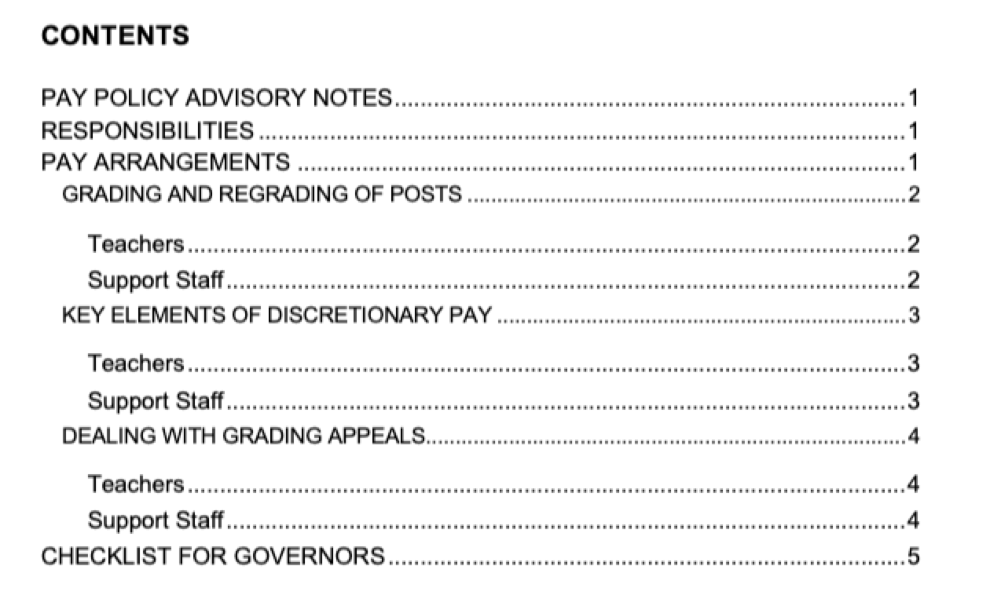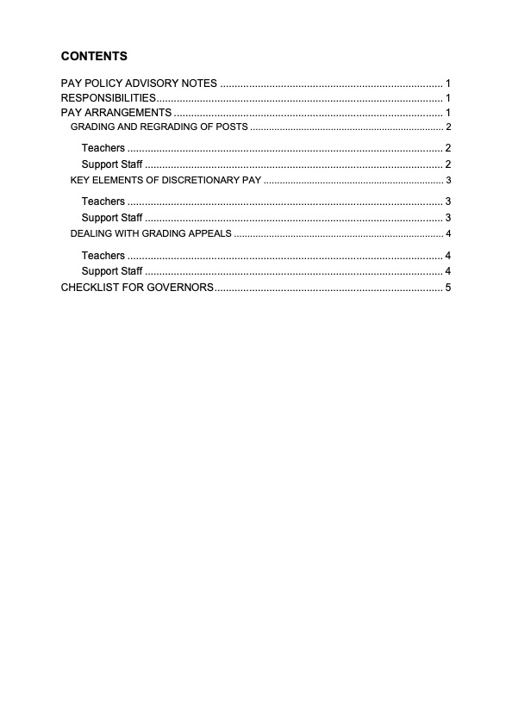


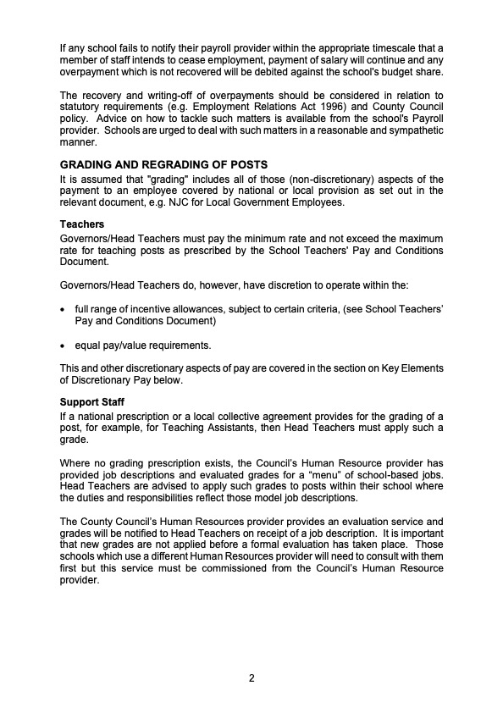

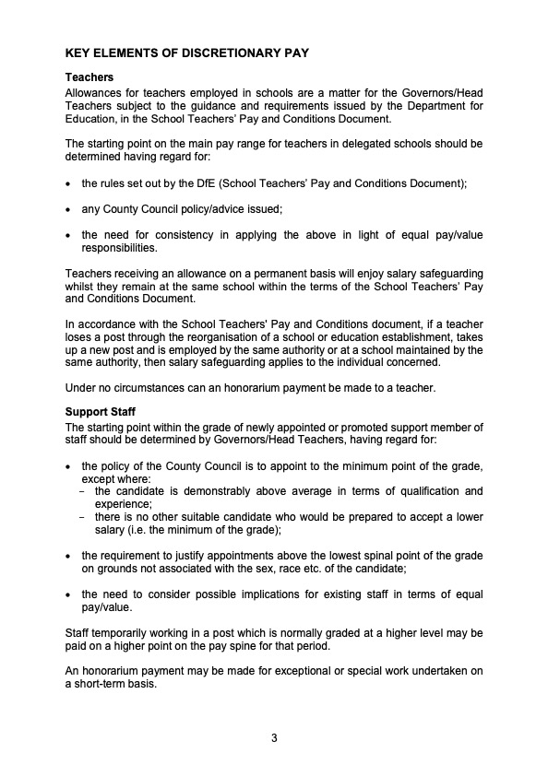



CHECKLIST FOR GOVERNORS

The checklist below is provided to further assist Governors in ensuring that all discretionary elements have been adopted and implemented.

- This school has adopted the LCC model Pay Policy

- The Governors are committed to the following actions as set out in the Pay Policy:

- Annual salary review timetable – The process will be followed, as identified in the pay policy.

- Annual Salary Reviews – For teaching staff these will be completed by no later than 31st October each year and for the Head Teacher this will be completed by 31st December each year.

- All teaching staff, including the Head Teacher, will receive written confirmation of the outcome of the annual salary review.

- A staff structure will be attached to the pay policy.

Signed ____________________ Date _____________________

Chair of Governors

